“THE LIVING LAST SUPPER”
An Easter Drama
PRESENTED BY
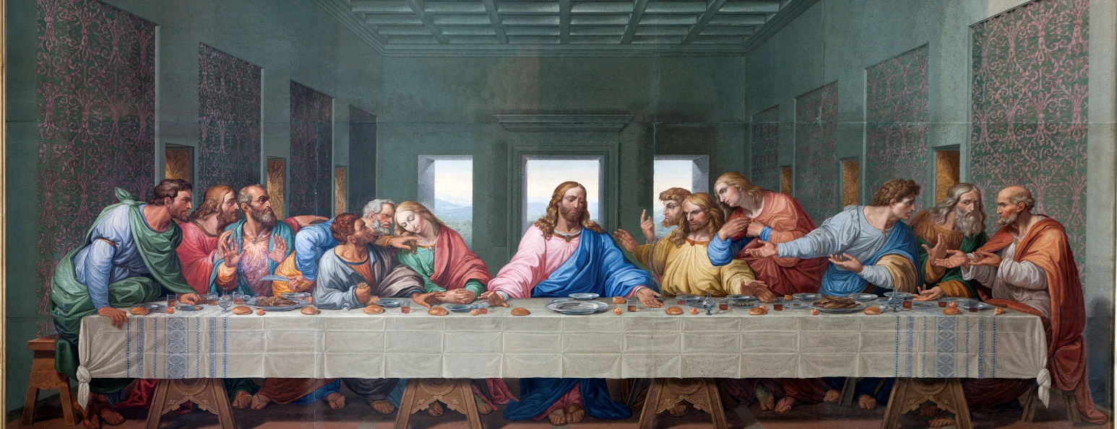
WAYESBORO CHURCH OF THE BRETHREN

“Is it I, Lord?”
Palm Sunday, April 5th, 2020
2:00 p.m. & 7:00 p.m.
GOOD FRIDAY, APRIL 10TH, 2020
7:00 p.m.

Public is Welcome 117 South Church Street
Free Admission Waynesboro, PA 17268
Handicap Accessible 717-762-3835

WAYNESBORO CHURCH OF THE BRETHREN
Visit us online at www..cobwaypa.org

